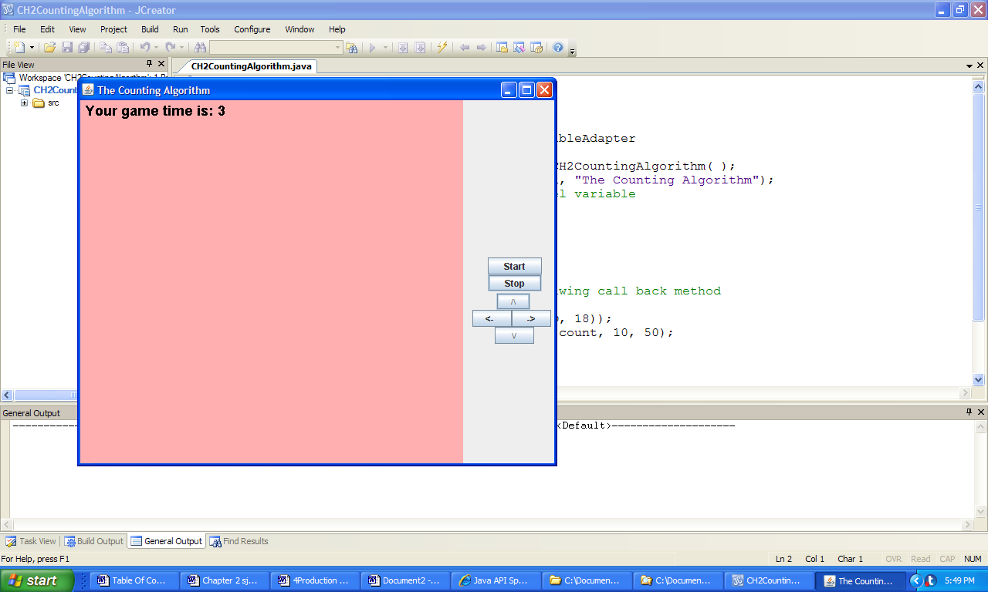

**Figure 2.13 The output produced by the application CountingSeconds three seconds after the Start button is clicked**.